CS 557 - Winter Quarter 2024 - Project #1 Report

# TITLE: STEP AND BLENDED-EDGED ELLIPTICAL DOTS

*Submitted by: Manogna Challoju*

*Email: challojm@oregonstate.edu*

This project renders an OBJ file with elliptical dots. The ellipse and lighting parameters uAd, uBd, uKa, uKd, uKs were set as uniform variables and could be dynamically adjusted. Perfragment lighting was applied to the rendered geometry. The vertex shader calculated vectors such as Normal, Light, and Eye, while the fragment shader computed ambient, diffuse, and specular lighting using the provided coefficients uKa, uKd, uKs, and the specular exponent uShininess.

The ellipse border, defined in s and t coordinates, was implemented using the equation:

**pow(((vST.s - sc) / Ar), 2) + pow(((vST.t - tc) / Br), 2);**

A smooth blend between the ellipse color and the background color was achieved using the smoothstep function with the uTol parameter. The resulting value was then used in the mix function to blend colors on the edge of the ellipse.

**myColor = mix(DotColor, BgColor, t)**

The project successfully implemented the following features

* Hard-edged elliptical dots
* Smooth-edged elliptical dots with varying uTol
* Correct elongation when varying uAd and uBd
* Per-fragment lighting

**Screenshots and Video:**

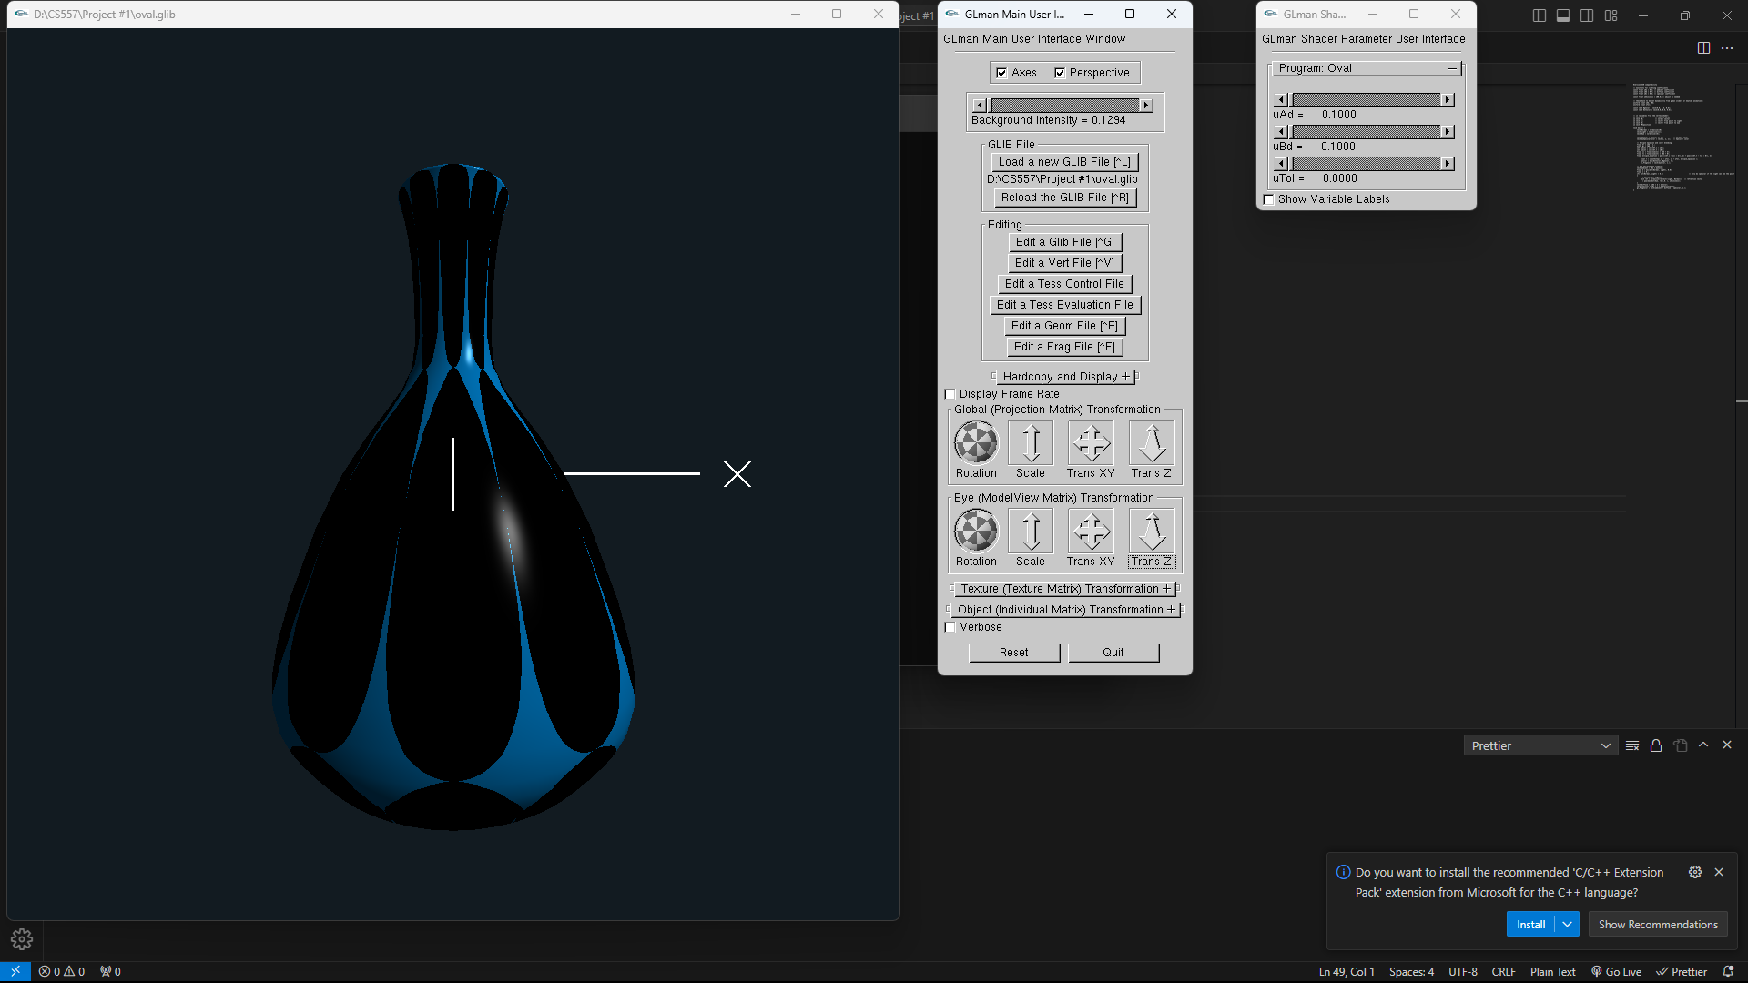

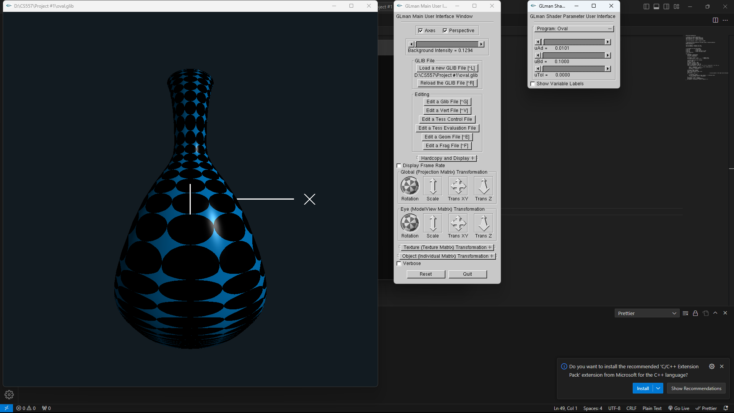

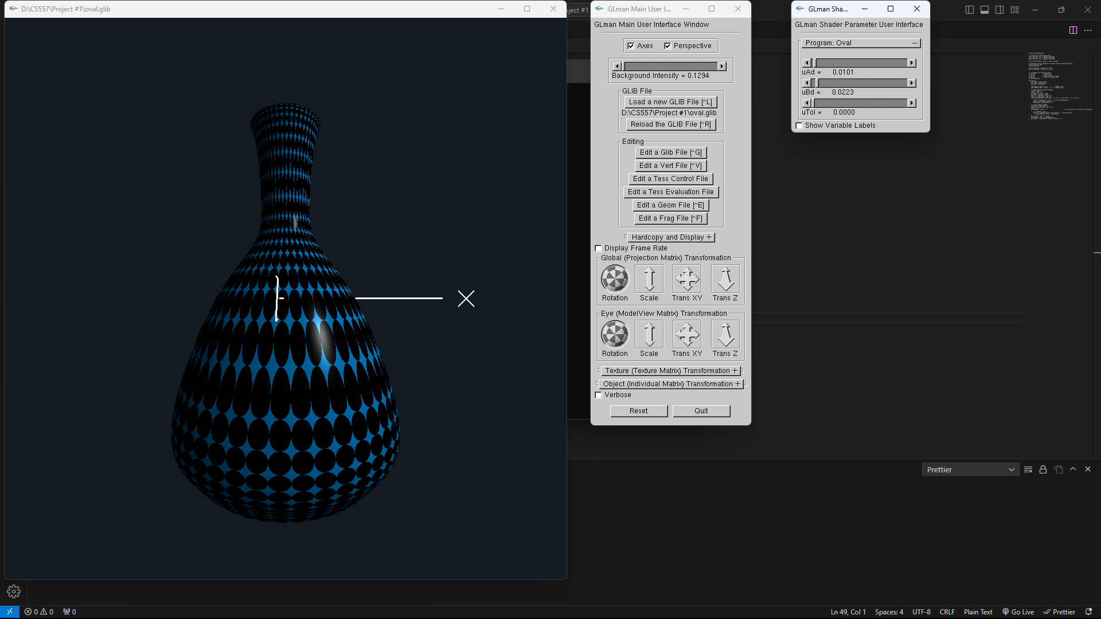

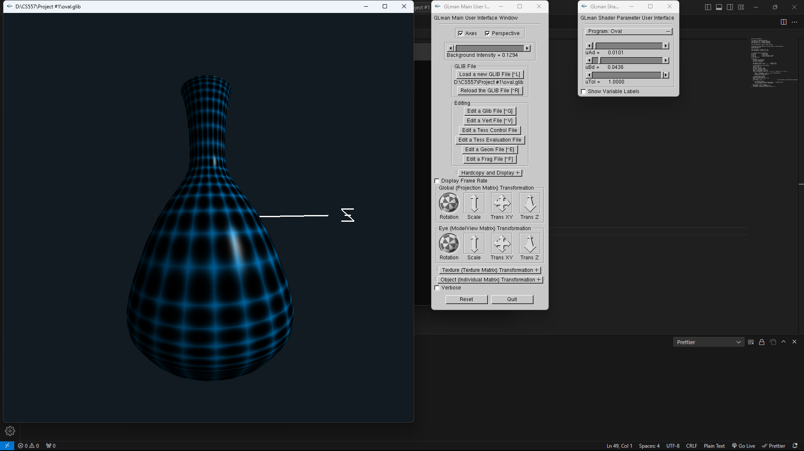

Kaltura Link -<https://media.oregonstate.edu/media/t/1_xdg7bwft>